MVP Over the Master Plan

Delivering Working Value When the Epic Is Too Big to Grasp
When an epic is so large that nobody on the team can hold it in their head, the instinct is to plan harder — bigger Gantt chart, more workstreams, more dependencies mapped in advance. It feels responsible. It is, in fact, the most dangerous thing you can do. A detailed plan for work you do not yet understand is not a plan; it is a forecast dressed up as a commitment. The alternative is not chaos. It is the disciplined opposite: ship the smallest piece of real, working value you can, learn from it, and let the next piece be shaped by what you just learned.

Why the Master Plan Fails in Complex Work
Traditional, plan-driven project management assumes that the scope is knowable at the start. You decompose the goal, estimate every task, sequence the dependencies, and execute the plan. This works beautifully when the work is well understood — building a warehouse, paving a road, rolling out a known package to a thousand laptops. The plan is reliable because the future is reliable.
Complex data and software work is not like that. The hardest questions — what does the source data actually look like, what do stakeholders really mean by “the report”, which transformations are correct, where the edge cases hide — cannot be answered from a planning room. They can only be answered by building something and looking at the result. In that world, a 200-line plan is not a map of the territory. It is a detailed map of a territory the team has never visited, drawn from rumour. The more detail it contains, the more confidently it points in the wrong direction.

The Cost of Planning What You Do Not Yet Understand
Every hour spent estimating a task you do not understand produces a number that feels precise and is almost certainly wrong. Worse, that number becomes a commitment. The team is then judged against a fiction invented before anyone had the information needed to make it true. Plans for unknown work do not reduce risk — they hide it, and they postpone the moment it becomes visible until it is most expensive to fix.

What an MVP Actually Is — and What It Is Not
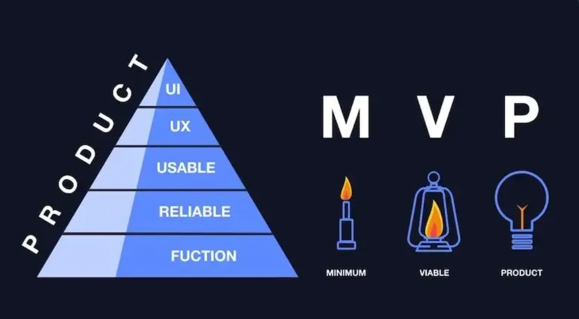
A Minimum Viable Product is the smallest slice of a larger goal that delivers real value to a real user and runs in the real environment. Every word carries weight. Smallest, because the point is to learn fast and cheaply. Real value, because a slice that nobody can use teaches you nothing. Real environment, because something that only works on a developer laptop has not reduced any of the risk that matters.
The most common misunderstanding is to confuse “minimum” with “unfinished” or “low quality”. An MVP is not a broken version of the full product. It is a complete, production-quality version of a deliberately narrow slice of it. The narrowing is in the scope, never in the quality. One report, for one business question, built properly and running in production, is an MVP. Five reports, all half-built and none deployable, are not.
- Minimum — Scope cut to the smallest thing that still answers a real question. Choosing the narrowest useful slice, not the largest that fits in a sprint.
- Viable — It actually works, end to end, to the team’s full Definition of Done. Production-grade, not a prototype held together with manual steps.
- Product — Deployed where the value is consumed, by the people who need it. Value that sits in an unmerged branch is not value — it is inventory.

MVP and the Heart of Scrum: Working Software Every Sprint
This is not a new idea bolted onto Agile — it is Agile. Scrum exists to turn an uncertain goal into a series of short, inspectable increments. The first value of the Agile Manifesto puts working software ahead of comprehensive documentation, and the Scrum framework operationalises that by demanding a potentially shippable increment at the end of every sprint. The MVP mindset is simply taking that demand seriously: instead of asking “how much of the epic can we plan”, the team asks “what is the smallest piece of this epic we can put into production this sprint?”
That question changes everything. It forces the epic to be cut vertically — a thin, complete slice from source to delivered value — rather than horizontally into layers that only have worth once the last layer lands. It converts the team’s biggest enemy, uncertainty, into its fuel: every increment retires a real risk and teaches the team something it could not have known by planning.
Dimension | Traditional Master Plan | MVP / Incremental Delivery
When scope is fixed | Up front, before anything is known | Continuously, as each increment teaches the team more
First working output | Near the end, after integration | End of the first sprint, in production
How risk is handled | Documented early, discovered late | Retired one slice at a time, early
Response to learning | Change request, re-planning, friction | Expected — reshapes the next slice
Value to the business | Arrives all at once, at the end (or not at all) | Compounds sprint by sprint from week one
Effect on a complex epic | Overwhelms the team with everything at once | Makes the epic graspable one slice at a time

The One Thing You Decide Up Front: The Platform
There is a crucial exception to “do not plan what you do not know”, and getting it wrong is one of the few mistakes an Agile team genuinely cannot iterate its way out of. The foundational platform must be chosen deliberately, up front. You can — and should — discover the requirements, the data shapes, and the right transformations slice by slice. But you cannot discover, slice by slice, whether you are building on the right database, the right cloud, the right data platform. Those choices are expensive and slow to reverse.
The rule is a clean split: decide the environment up front; discover the product incrementally. Choose the platform, the governance model, and the architectural pattern before sprint one — then never let that decision be an excuse to also plan the entire epic in advance.
For the programme this article is grounded in, that foundational decision is Databricks, and getting its architecture right is what makes fast MVP delivery possible rather than reckless.

Iterate the Product, Not the Foundation
Requirements are cheap to change and should change often. Infrastructure is not. The teams that succeed make exactly one big up-front decision — what we are building on — and then refuse to make any others until the work itself forces the question. Everything above the platform is learned. The platform is chosen.

Getting Databricks Right: The Medallion Architecture
Databricks structures data using the Medallion Architecture — a progressive refinement of data through three layers, conventionally named Bronze, Silver, and Gold. Each layer raises the quality and business-readiness of the data.
- Bronze — Raw. Source data ingested as-is, with minimal transformation. A faithful copy of what the source systems sent, kept so you can always reprocess from the truth.
- Silver — Conformed. Cleansed, validated, de-duplicated, and joined into a consistent enterprise view. Where data from different sources is reconciled and made trustworthy. Often the most reused layer.
- Gold — Curated. Business-level, aggregated, consumption-ready tables built for a specific purpose: the report, the dashboard, the model. The layer the business actually sees and makes decisions from.
The “three steps” as often described | What it really is in Databricks | Where it sits
1. Report straight off external sources | Lakehouse Federation — querying the source live, without copying data in | A connectivity choice, not a Medallion layer. Fast to stand up; you depend on the source’s availability.
2. Copies in SQL, refreshed from source | Ingestion into Bronze, then cleansing into Silver | The first two Medallion layers. You own a governed copy and control how it refreshes.
3. Data recreated independently in Databricks | Curated Gold tables, governed in Unity Catalog | The Gold layer. Where durable business value is served from.

The MVP as a Thin Slice Through Bronze, Silver and Gold
The production MVP is a thin vertical slice that threads all three layers for one narrow use case. You pick a single business question, ingest just the source data that question needs into Bronze, conform just that data in Silver, build the one Gold table that answers the question, and deploy it. Narrow scope, full depth.
-- Bronze: land the one source this slice needs, as-is.
CREATE OR REFRESH STREAMING TABLE bronze_meter_reads
AS SELECT * FROM cloud_files('/landing/meter_reads', 'json');
-- Silver: cleanse and conform just that data.
CREATE OR REFRESH STREAMING TABLE silver_meter_reads AS
SELECT site_id, CAST(read_ts AS TIMESTAMP) AS read_ts, kwh
FROM STREAM(bronze_meter_reads)
WHERE kwh IS NOT NULL AND read_ts IS NOT NULL;
-- Gold: the one business-ready table the report consumes.
CREATE OR REFRESH MATERIALIZED VIEW gold_daily_site_output AS
SELECT site_id, date(read_ts) AS day, SUM(kwh) AS total_kwh
FROM silver_meter_reads
GROUP BY site_id, date(read_ts);
Federation is the secret weapon of the first MVP. Before committing engineering effort to ingestion pipelines, an early sprint can federate directly to the source and ship a working report in days. If the report proves its worth, the next MVP replaces the live federation with a proper Bronze-to-Gold pipeline. If it does not, you have lost days, not a quarter.

The Business Function Backlog: The Iceberg Model
A large backlog is not a problem. It is a sign of a healthy, engaged business function that has been honest about everything it wants to improve. A bank’s Finance function will naturally accumulate hundreds of items over time — regulatory requirements, management reporting requests, audit findings, system migrations, CSI feedback from live services. The backlog representing five or more years of potential work is not a cause for alarm. It is a cause for good Product Ownership.
The mistake is not having a large backlog. The mistake is treating every item in it as equally urgent, equally refined, and equally deserving of the team’s attention right now. That mistake is what turns a healthy backlog into a source of paralysis.

The Iceberg: Only the Top Stories Need to Be Ready
Mike Cohn’s iceberg analogy (https://www.youtube.com/watch?v=D2r2KryYAaY) captures this perfectly.
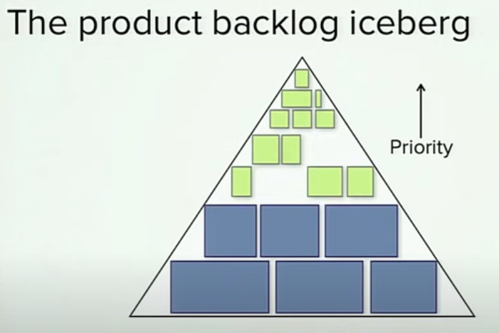
Think of the backlog as an iceberg floating in the ocean. The stories visible above the waterline — roughly the top twenty — are fully refined: written in detail, estimated, acceptance criteria agreed, dependencies understood, and ready to be pulled into a sprint. Everything below the waterline exists, and it matters, but it is rough. It is headings, ideas, regulatory mandates noted down, stakeholder requests captured. It does not need to be detailed yet, because it is not needed yet.
As the team in sprint planning sessions pulls stories off the top of the iceberg — completing them sprint by sprint and delivering them as working software — the iceberg rises. Stories that were just below the waterline float up into view. The Product Owner refines them, adds detail, agrees acceptance criteria, and they become the next set of sprint-ready stories above the waterline. The stories that were deep underwater move closer to the surface. The backlog is always large. The refined, actionable portion at the top is always small, focused, and manageable.
There is nothing wrong with the Product Owner, pulling the team into backlog grooming sessions. In fact, because the Product Owner is typically a businessperson and not a technical person (developer, technical architect, business analyst etc.) the team involved in backlog grooming sessions where the backlog in Jira is tackled head on is a fantastic session. I set up these sessions every Wednesday each week of a two-week sprint and we would plan only on the backlog for the next sprint. It was incredible but we decided not to bring anything into the sessions that could make a mess because as discussions heated up these could start being thrown around.
This is the natural rhythm of a well-run Scrum programme, and it is the answer to the question “how do you manage a backlog that represents years of work?” You do not plan it all in advance. You keep the top twenty sharp and let the rest float up in its own time.

The Product Owner Is the Waterline
The mechanism that makes the iceberg work is the professional and empowered (by business) Product Owner — the person who, on behalf of the business function, owns and manages its requirements because they understand what the function needs, why it needs it, and in what order it needs it. This is not a technical role and it is not a proxy role. It is a senior business representative who has enough authority to speak for the function and enough knowledge of its operations to translate ideas into actionable requirements.
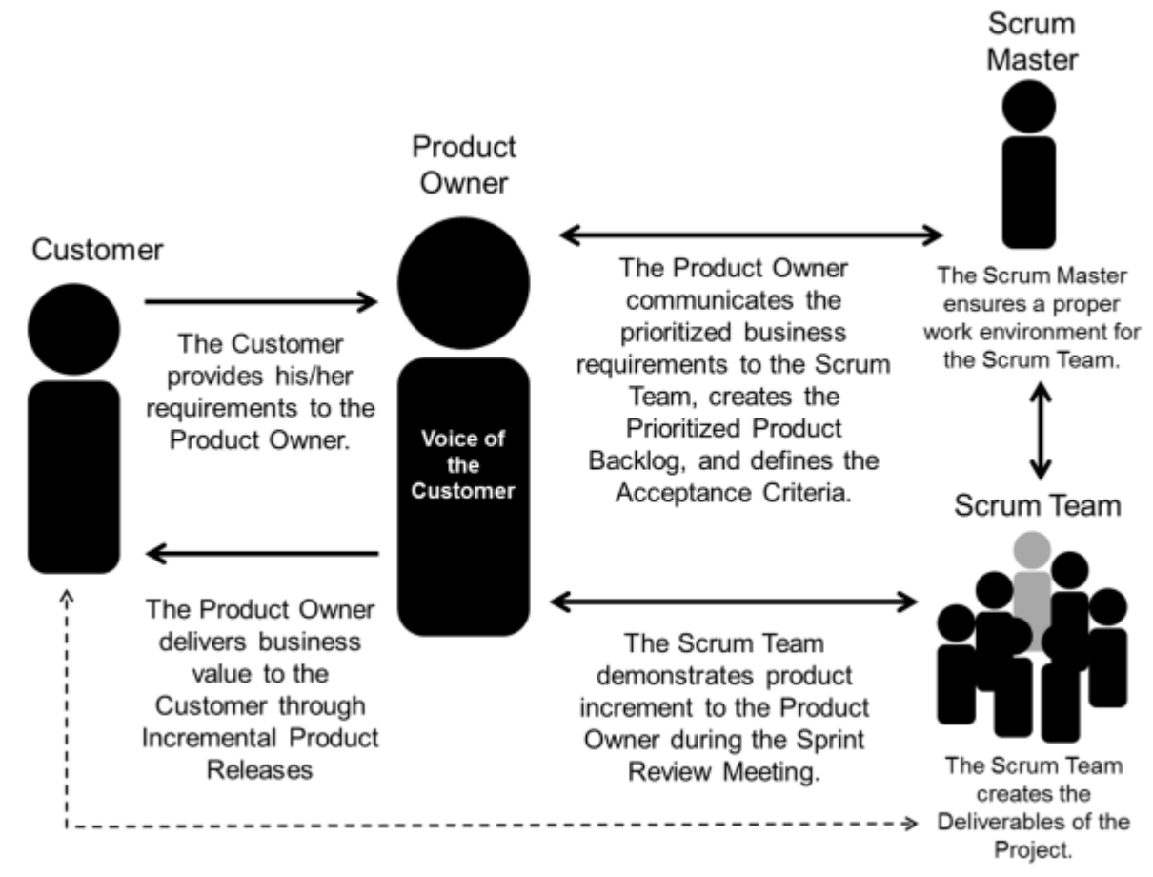
The Product Owner’s defining responsibility is closing the loop from idea to done. In a truly Agile business function, that loop looks like this: a business idea or need is captured as a rough backlog item below the waterline. As it rises, the Product Owner shapes it into a properly written requirement — a user story with clear acceptance criteria that the team can build against. As a businessperson the Product Owner does not need to explain the technical requirements. They use the Scrum User Story format:
As a [type of user]
I want to [action the user wants to perform]
So that [the business value or benefit the user gets]
Practical Examples
- E-Commerce Customer: "As a registered shopper, I want to save my payment information, so that I can check out faster on future purchases."
- Mobile App User: "As a frequent traveler, I want to switch the app to dark mode, so that I can save battery and reduce eye strain in low light." [1, 2]
- HR Manager: "As an HR admin, I want to filter applicants by years of experience, so that I can quickly identify the most qualified candidates."
The team takes on the User Story in the Backlog Grooming sessions and Sprint planning sessions and adds in the detail. Then the User Story is taken into the sprint and built in a sprint to present it at the Sprint Review. The Product Owner inspects the increment against the acceptance criteria and either approves it — done — or rejects it with specific feedback. If rejected it goes back into the Product Owners backlog. Once approved, the increment is shipped to production. That is done done: working software in the hands of the people who need it, not sitting in a staging environment awaiting sign-off. At that point, and only at that point, the story leaves the iceberg permanently and enters the Service Catalogue as a live, supported service.
This idea-to-done-done cycle is the heartbeat of an Agile business function. Every sprint it turns at least one business idea into working software. Over time, the Catalogue grows, the iceberg rises, and the function accumulates real capability rather than a growing inventory of half-finished work.
Without a real Product Owner, the waterline disappears. Nobody translates ideas into requirements the team can act on. Nobody approves the increment with authority, so done never becomes done done. Refinement spreads thinly across the whole backlog and achieves nothing. The iceberg stops rising cleanly and becomes a tangled mass that nobody can navigate. The Product Owner is not a nice-to-have role in a business function — they are the mechanism by which a large, healthy backlog stays navigable and by which ideas reliably become working software.
The Product Owner’s core responsibilities in a business function:
- Translating ideas into requirements. The Product Owner understands the function’s needs well enough to turn rough backlog items into properly written user stories — acceptance criteria agreed, dependencies understood, ready for the team to build.
- Maintaining the waterline. At any given time, roughly the top twenty stories are refined and sprint-ready. Everything below is captured but deliberately left rough until it floats up.
- Approving the increment — done to done done. At the Sprint Review, the Product Owner inspects the increment against the agreed acceptance criteria and approves it. Approval is the trigger for shipping to production. No approval, no shipment — and approval means the Product Owner is satisfied it meets the business need, not merely that the technical work is complete.
- Managing stakeholder expectations. The Product Owner is the single point of truth for what is coming, when, and why other things are not. New requests go into the backlog at the right depth — they do not jump the queue unless the Product Owner explicitly decides they should.

Vertical Slicing Inside the Business Function
The iceberg model also shapes how stories are written. A Finance function should not place “build the management reporting suite” as a single item in the backlog. That is a heavy boulder, not a story — it cannot float above the waterline because it is too large to refine, estimate, or deliver in a sprint. Instead, it should be decomposed into thin, vertical slices: “month-end P&L variance report for the CFO, sourced from the general ledger, live in production”. That is one story. It can be refined, delivered, and released as a working increment. The suite emerges sprint by sprint as each slice floats up, is refined, and is delivered.
This discipline also protects the business function from being overwhelmed by what the team delivers. Done right, the function receives one complete, production-ready capability per sprint — something it can absorb, embed into its processes, and build institutional knowledge around before the next one arrives.

Connecting to ITIL: Pipeline, Catalogue, CSI, and Retirement
ITIL — the Information Technology Infrastructure Library — is the most widely adopted framework for managing IT services. Where Scrum describes how to build things, ITIL describes how to run them once built, how to keep improving them, and — crucially — how to know when to stop running them. For business functions working alongside a Scrum delivery team, ITIL provides the governance vocabulary for the full lifecycle of every service the team ships.
ITIL v3 has 5 Lifecycle Phases: Service Strategy, Service Design, Service Transition, Service Operations and Continual Service Improvement. A Scrum Team comes into play after Service Strategy, building in Service Design and releasing working software along the Service Pipeline through Service Transition and into Service Operations. Ideas for improvement or next versions of software are fed through the Continual Service Improvement Lifecycle Phase.

The four ITIL concepts that connect most directly to the iceberg and MVP model are the Service Pipeline, the Service Catalogue, Continual Service Improvement (CSI), and Service Retirement. Together they describe what happens to a story after it leaves the top of the iceberg.

The Service Pipeline: Stories in Flight
The Service Pipeline is the set of services currently being built — everything that has risen above the iceberg’s waterline, been pulled into a sprint, and is on its way to production. For the business function, the pipeline answers the question “what is coming, and when?” in a concrete, sprint-by-sprint sense.
The Finance function’s Product Owner, looking at the pipeline, can see that “automated month-end P&L variance report” is two sprints away and “budget vs actuals dashboard by cost centre” is four sprints away. This gives the function enough lead time to prepare — train users, update process documentation, notify auditors — without locking the delivery team into false precision about everything further out. Everything below the waterline is still rough; only what is in the pipeline is committed.
The pipeline also makes trade-offs honest. When a new regulatory requirement arrives with an urgent deadline, the Product Owner can point to the pipeline, show what would need to move, and have a genuine conversation about priority rather than simply absorbing the new item invisibly into a backlog nobody reads.

The Service Catalogue: What Is Live and Supported
When a story completes its sprint, passes the Sprint Review, and is deployed to production, it does not simply disappear into the ether. It becomes an entry in the Service Catalogue — the register of services currently live, supported, and available to users. In ITIL terms, a service only earns its place in the Catalogue when it is fully operational: documented, owned, with a known refresh schedule and a clear process for handling failures.
For the bank’s Finance function, the Catalogue might look like this after six months of delivery:
- Month-end P&L variance report — live, refreshed nightly from the general ledger, owned by the Finance Data team.
- Cost centre budget vs actuals — live, self-service via the Finance dashboard, refreshed daily.
- Intercompany reconciliation summary — live, automated exception flagging included, owned by the Group Reporting team.
Each of these was once a rough idea below the iceberg’s waterline. It floated up, was refined, was delivered as an MVP slice threading Bronze through Silver to Gold in Databricks, and is now a supported service. The Catalogue makes that journey tangible. It is the answer to “what has the team actually delivered?” — not in story points, but in services people rely on every working day.
Crucially, the Catalogue also makes something else visible: what the team used to do manually that can now stop. When the automated month-end P&L report goes live in the Catalogue, the Excel-based manual process it replaces does not need to run alongside it indefinitely. That is where Service Retirement becomes essential.

Service Retirement: Closing the Loop
This is the step that most delivery programmes skip, and skipping it is expensive. Every time a new Databricks-powered service enters the Catalogue, there is almost certainly an older service it supersedes — a manual Excel report, a legacy SQL query run by hand each month-end, a third-party tool the business paid for before the data platform existed. If the old service is not formally retired, the business function ends up running both in parallel: the new automated service and the old manual process, side by side, consuming time, creating confusion about which number is correct, and eroding trust in the new platform.
Service Retirement in ITIL is the formal process of decommissioning a service that is no longer needed. In the Finance function context it means: once the Databricks-powered month-end P&L report has run successfully for an agreed number of cycles and the business has validated its output, the manual Excel process is switched off. The spreadsheet is archived. The time the Finance analyst spent producing it every month is freed for higher-value work. The Gold table in Databricks is the single source of truth, and there is no fallback that quietly undermines it.
Retirement also feeds back into the backlog. The effort previously spent running and maintaining the retired service is capacity that can now be redirected — sometimes to further items on the iceberg, sometimes to improving the new service through CSI. Either way, the loop closes cleanly.

Continual Service Improvement: What Gets Better
CSI is ITIL’s answer to the question every business function eventually asks: “the service is live, but it is not quite right yet — what now?” It is a formal lifecycle stage in which live Catalogue services are measured, gaps are identified, and improvement actions are fed back into the backlog — where they take their place in the iceberg, floating up to the waterline in priority order alongside new capability work.
For the Finance function, CSI in practice looks like this: the month-end P&L report goes live. After two cycles of real use, the team identifies that the report runs too slowly on the last day of the month, one cost centre is missing due to a data mapping error, and the CFO wants a prior-year comparison column. These three items are raised as properly written backlog stories. They go below the waterline, are sized relative to other work, and float up in the order the Product Owner decides. They do not bypass the iceberg. They join it.
CSI prevents two failure modes that commonly afflict business functions after a delivery programme:
- The “done and forgotten” failure. A service is delivered, the team moves on, and nobody owns the ongoing quality of what was built. The Gold tables drift. The numbers stop being trusted. Users rebuild the shadow spreadsheets. CSI makes improvement of live services a permanent, first-class source of backlog items — not an afterthought that surfaces only when something breaks.
- The “never good enough to launch” failure. The business function refuses to accept a service into the Catalogue because there are still improvements to make, holding up formal go-live indefinitely. CSI solves this by separating launch from perfection: the service goes live when it is viable, and the improvements join the backlog as CSI stories to be delivered in subsequent sprints. The iceberg keeps moving.

The Full Lifecycle: From Waterline to Retirement
Taken together, these four ITIL concepts give a business function a complete operating model for living alongside a Scrum delivery team across the full life of every service — from rough idea at the bottom of the iceberg to formal retirement when the next generation supersedes it.
Stage | ITIL concept | What is happening | Iceberg position
Rough idea captured | Backlog (below waterline) | Item exists, not yet refined | Deep below the waterline
Rising toward readiness | Backlog refinement | Product Owner adds detail as the item approaches the top twenty | Approaching the waterline
In development | Service Pipeline | Story is in a sprint, being built as an MVP slice | Above the waterline, in flight
Live and supported | Service Catalogue | Completed increment is in production, owned, documented | Delivered — in the Catalogue
Being improved | CSI | Feedback from use generates new backlog stories | New items enter the iceberg
Superseded and closed | Service Retirement | Old manual process or legacy service formally decommissioned | Removed from the Catalogue
The Finance function that operates this model never drowns in its backlog, because the backlog is an iceberg — large by design, but only ever sharp at the top. It never loses track of what the team has delivered, because the Catalogue is the living record. It never lets good services decay, because CSI keeps feeding the iceberg. And it never wastes effort running old processes alongside new ones, because Retirement closes the loop every time a new service supersedes an old one.

Is Your Epic About to Overwhelm the Team?
Complex epics overwhelm teams in recognisable ways, and the warning signs appear long before the deadline does.
Signs the epic is too big:
- The team cannot describe what “done” looks like for the epic without reading a long document.
- Estimates are demanded for work nobody has the information to estimate yet.
- Sprints end with progress reports instead of working, deployed output.
- Stories are sliced horizontally — “build all the ingestion”, “then all the transforms” — so nothing is usable until the end.
- The plan assumes facts about the source data that no one has actually verified.
- Value is promised “once the whole thing is finished” — a date that keeps moving.
Signs it has been sliced well:
- Each sprint ends with one more thin slice live in production.
- The team can point to a real user getting real value from work shipped weeks ago.
- Stories are sliced vertically — each one threads source to delivered value.
- When the team learns something surprising, the next slice absorbs it without a crisis.
- The platform was decided once, up front, and is no longer up for debate.

Why This Compounds: Learn, Iterate, Improve
The deepest argument for MVP over the master plan is not speed — it is learning. A complex epic is, at its core, a pile of unknowns. Every MVP you ship converts one of those unknowns into knowledge: how the source data really behaves, what the stakeholder actually meant, how long the pipeline really takes to run, where data quality really breaks down. The team that has shipped four MVPs is not just four slices closer to done — it understands the problem in a way no amount of up-front planning could have produced.
That learning compounds. The fifth slice is faster than the first because the team now has working pipelines to extend, conventions that have proven themselves, and a Definition of Done that has met production. This is the empirical engine at the heart of Scrum — transparency, inspection, adaptation — applied to delivery.
A massive traditional plan front-loads all the deciding into the moment of least knowledge and then spends the rest of the project defending those decisions against reality. The MVP approach does the opposite: it makes the smallest possible decision, learns from it, and earns the right to make the next one. For an epic too big to grasp, that is not just a nicer way to work. It is the only way that reliably ends in a working solution.
The Bottom Line. Decide the foundation — Databricks, the Medallion architecture, the governance model — deliberately and up front. Appoint a qualified Product Owner for every business function backlog and let them manage it as an iceberg: the top twenty stories sharp and sprint-ready, everything else captured but rough, rising into view as delivery creates space. Use the ITIL Service Pipeline to track what is in flight, the Service Catalogue to make delivered value visible and governed, CSI to feed improvement stories back into the iceberg, and Service Retirement to formally close out every legacy process a new service supersedes. Then deliver the epic as a series of thin, complete MVP slices, each one live in production, each threading Bronze to Gold for a single real question. Small, focused, working delivery beats a big, confident, wrong plan every time.
Note: The above is not easy to do.
Retrospectives where the team can discuss how they can improve is the way to win.

Further Reading
- The Agile Manifesto — Beck et al.
- The Official Scrum Guide — Schwaber & Sutherland
- Databricks — What Is the Medallion Architecture?
- Databricks Documentation — Medallion Lakehouse Architecture
- Databricks Documentation — Lakehouse Federation
- Mike Cohn — Vertical vs Horizontal Story Slicing
- ITIL 4 Foundation — PeopleCert
- Mike Cohn — The Product Backlog Iceberg

